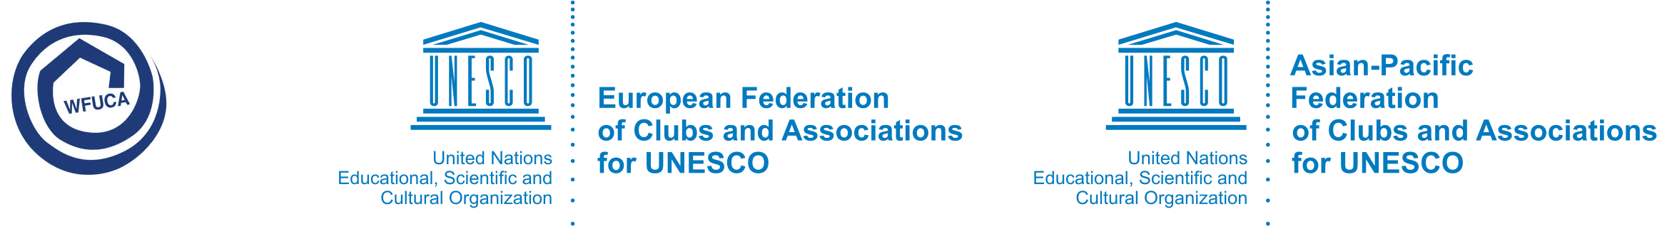

IV on-line Europe-Asia Forum on Education “Sustainable development in our society”
30-31 October, 2021

REGISTRATION FORM

Please send this information sheet back to the Organizing Committee of the Forum by October 8th, 2021.

E-mail: sabina.kazfuca@gmail.com cc: efucaoffice@gmail.com

Personal Information
Name of Organization*:
First name*: | Tel*:
Second name*: | E-mail*:
Title*:
Academic title*:
Position*:

Title of the presentation*:

Brief summary* (maximum 300 words):

